

**Veermata Jijabai Technological Institute, Mumbai 400019**

**Experiment No.:** 05

**Aim:** To perform association rule mining

**Name:** Kiran K Patil

**Enrolment No.:** 211070904

**Branch:** Computer Engineering

**Batch:** D

**Theory:**

Association rule mining is a data mining technique that is used to discover interesting relationships, patterns, and associations in large datasets. It is particularly useful in market basket analysis, where the goal is to identify patterns of co-occurrence among items in transactional databases. Association rule mining is widely used in fields like retail, e-commerce, and recommendation systems.

The most commonly used algorithm for association rule mining is the Apriori algorithm. Here's a basic overview of how it works:

1. **Support**: Support measures how frequently an itemset (a set of one or more items) appears in the dataset. It is defined as the ratio of the number of transactions containing the itemset to the total number of transactions. Item sets with low support are typically not considered for further analysis.
2. **Confidence**: Confidence measures how often the items in an itemset A appear together in the same transaction when itemset A appears. It is defined as the ratio of the support of the itemset {A, B} to the support of itemset A. High confidence values indicate a strong association between the items.
3. **Lift**: Lift is a measure of how much more often itemset A and itemset B occur together than would be expected if they were statistically independent. It is defined as (support{A, B}) / (support{A} * support{B}). A lift value greater than 1 suggests a positive association, a lift value equal to 1 suggests independence, and a lift value less than 1 suggests a negative association.

The Apriori algorithm uses these measures to find frequent itemsets and generate association rules based on user-defined support and confidence thresholds. The algorithm follows these steps:

1. Find all item sets with support above a user-specified minimum support threshold.
2. Generate association rules from the frequent itemsets with confidence above a user-specified minimum confidence threshold.

Association rule mining is used in various applications, including:

* **Recommender systems**: It helps identify which items are frequently bought together, enabling personalized recommendations.
* **Market basket analysis**: Retailers use it to understand customer purchase patterns and optimize product placement.
* **Healthcare**: Discovering associations in patient records can help in medical diagnosis and treatment planning.
* **Fraud detection**: Identifying patterns of fraudulent transactions or behaviors.

It's worth noting that while association rule mining is a powerful technique for discovering associations in data, it has its limitations, such as the potential for generating many spurious rules in large datasets. Researchers have developed more advanced algorithms, like FP-growth, to address some of these limitations.

**Implementation:**

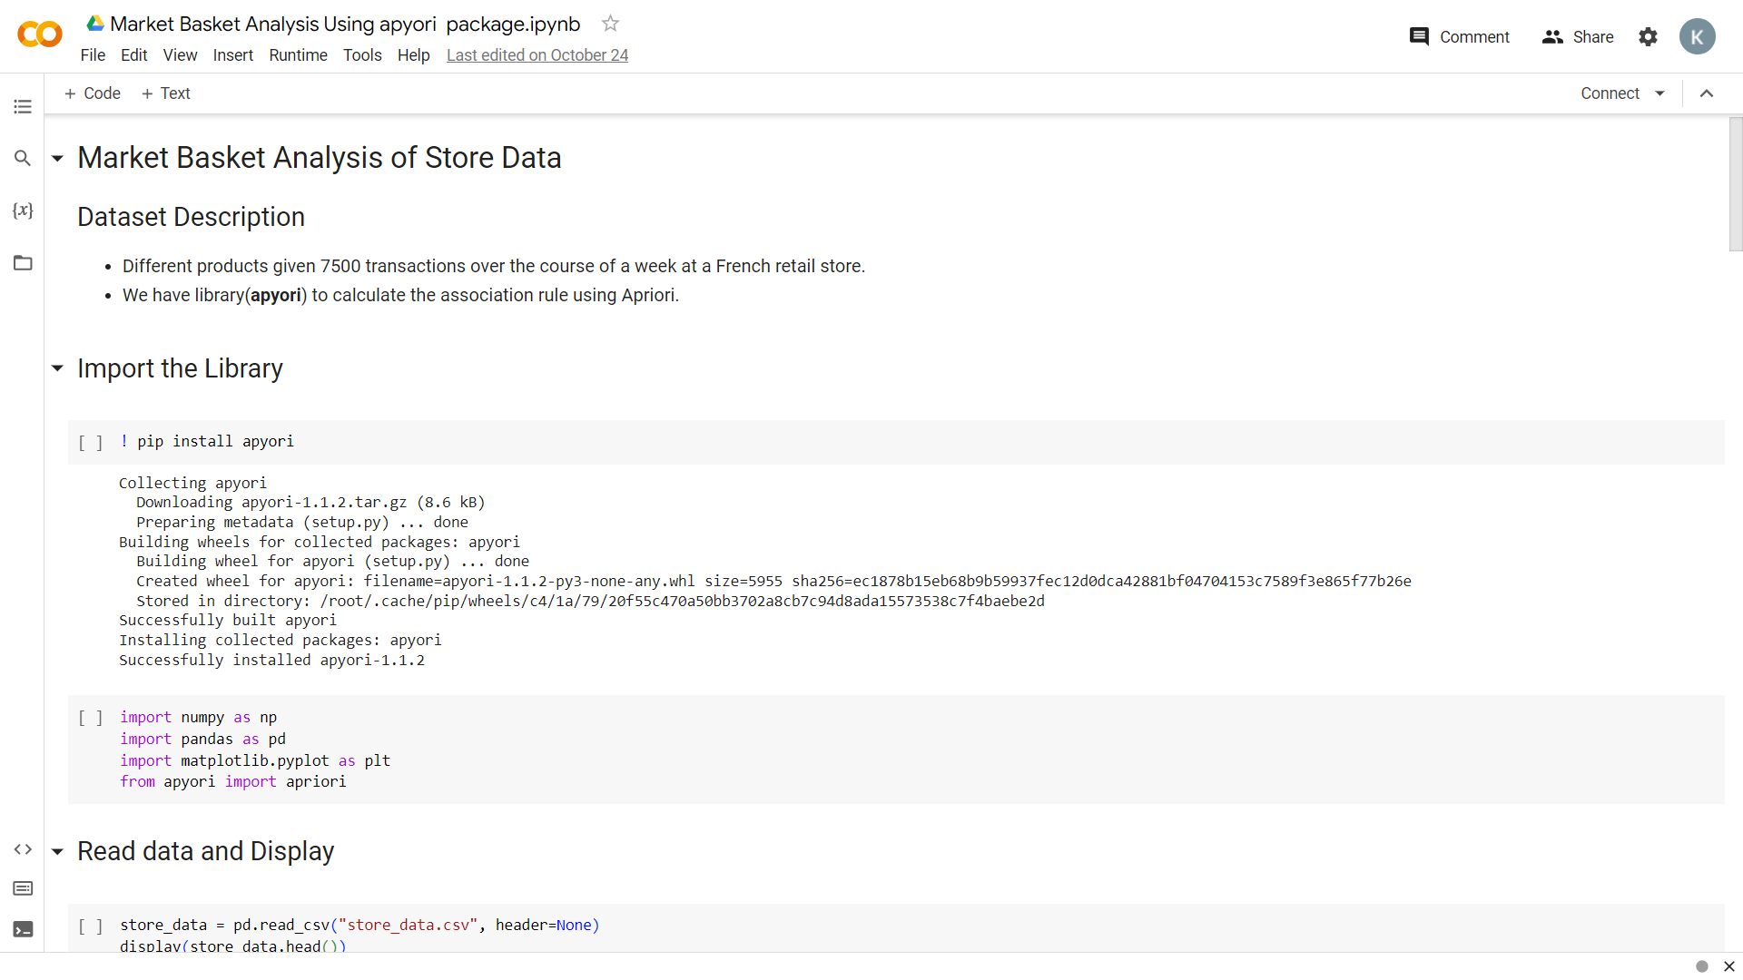

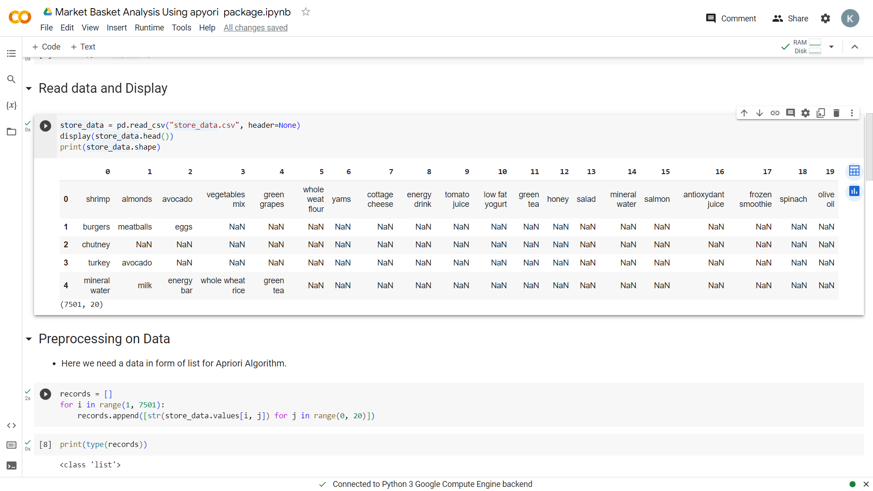

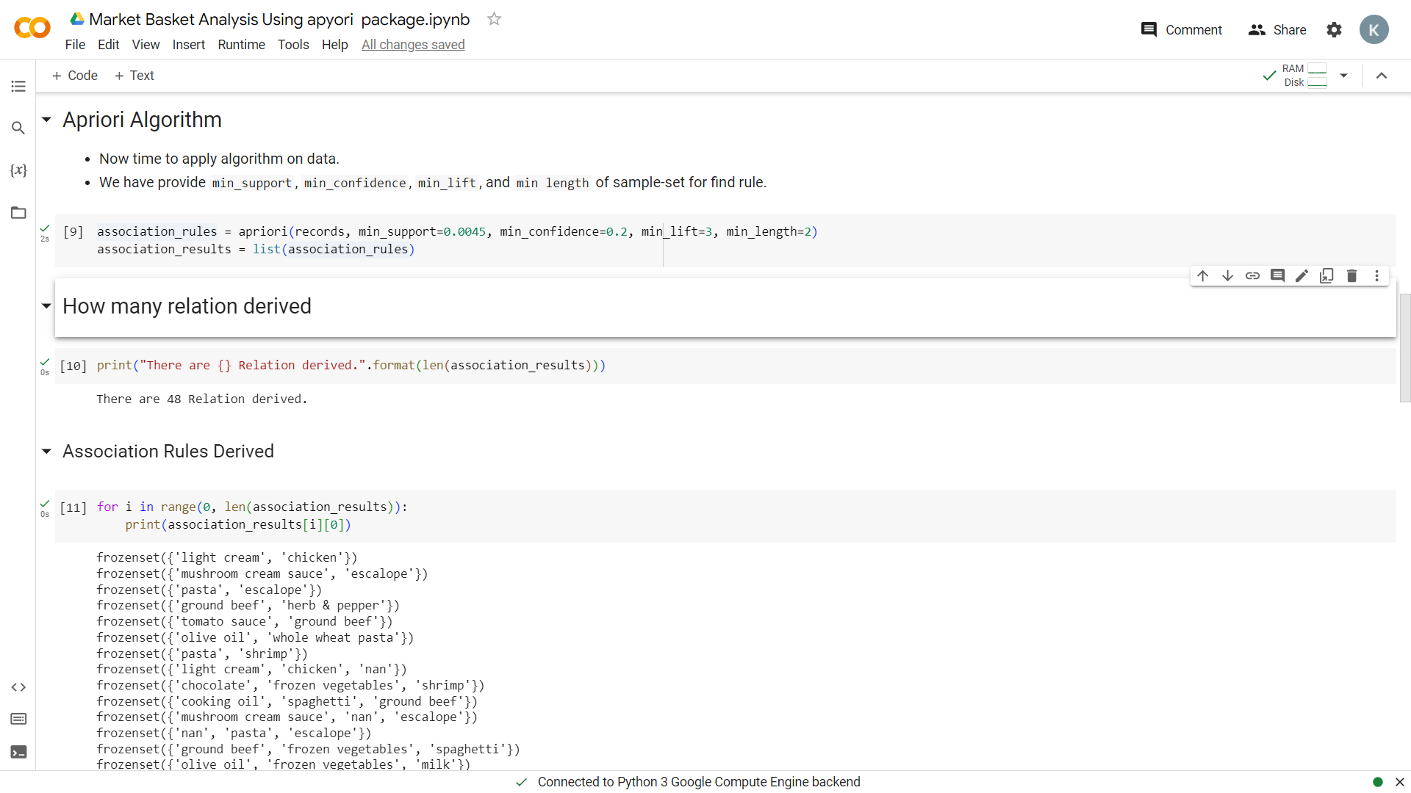

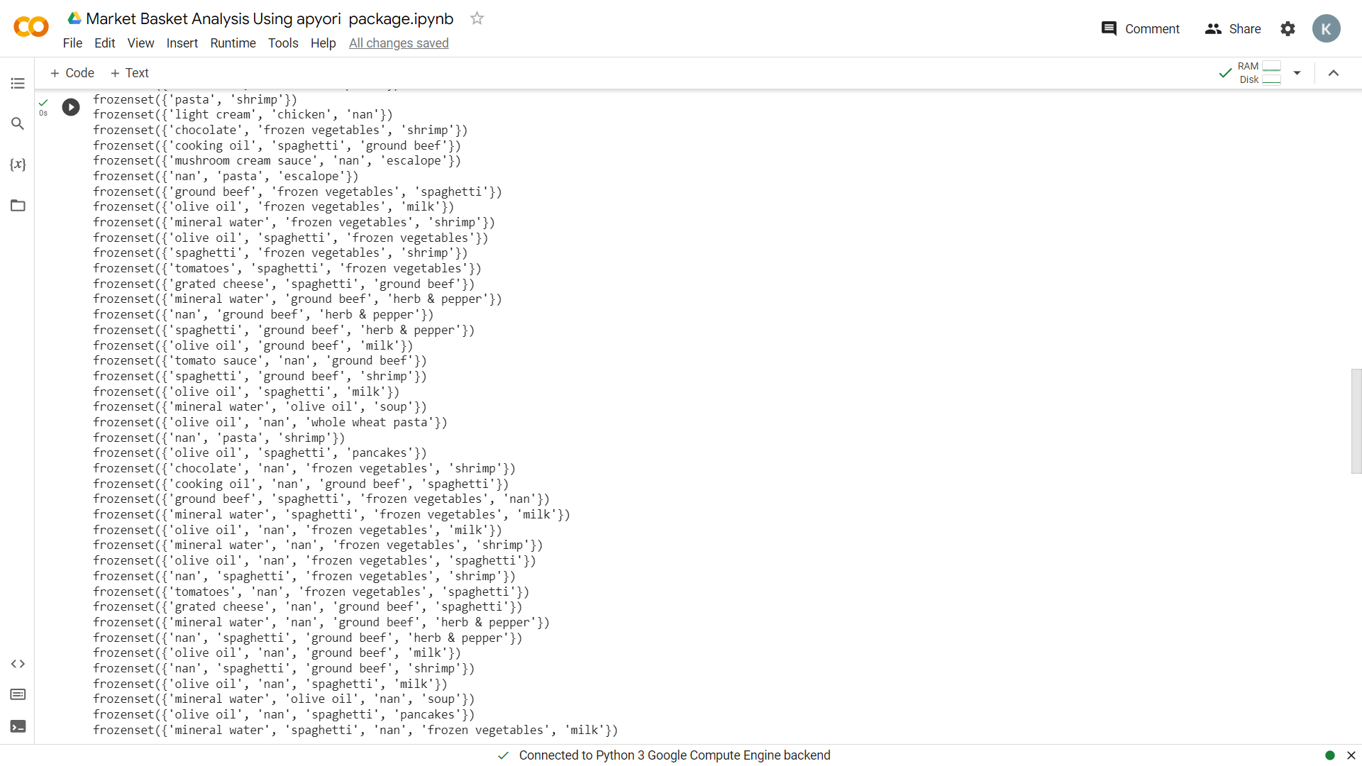

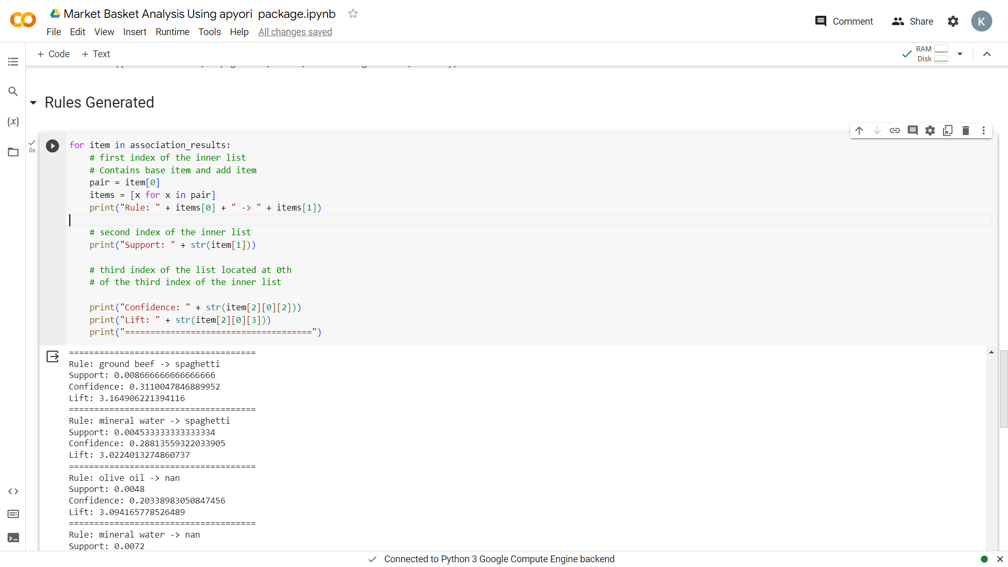

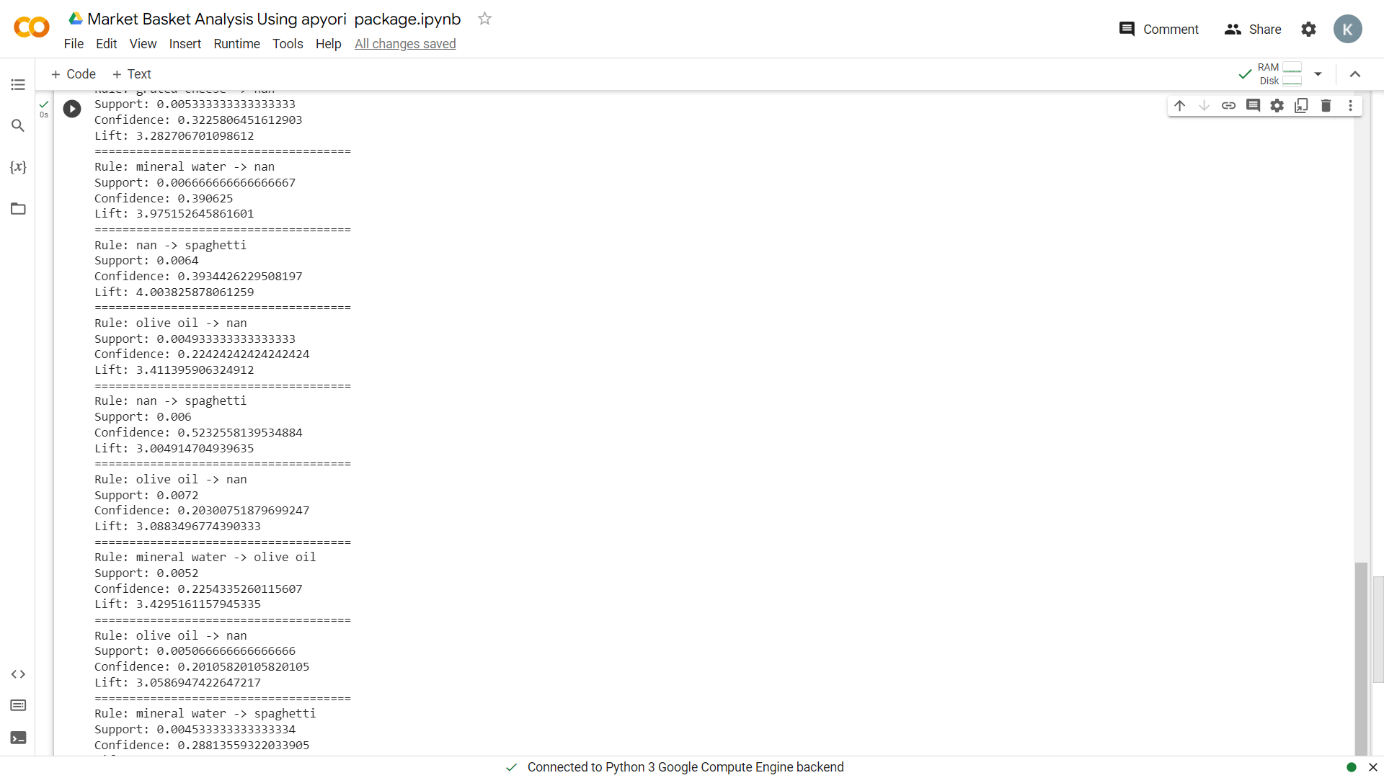

**Conclusion**:

In conclusion, association rule mining is a valuable data mining technique used to uncover meaningful relationships and patterns in large datasets. It's particularly useful for applications like market basket analysis, recommendation systems, healthcare, and fraud detection. By identifying associations between items or events, businesses and researchers can make informed decisions, improve customer experiences, and gain valuable insights from their data. However, it's important to set appropriate support and confidence thresholds to filter out relevant results and avoid generating too many spurious rules in extensive datasets.